Week 3 | Week 4: | Week 5: | Week 6: | Week 7:
Theme: British Destinations - Cornwall | Theme: Black History Month – Space Scientists | Theme: Black History Month - Windrush | Theme: Black History Month – Bus Boycotts | Theme: Black History Month – Voices Series
Extracts:  - Cornwall with Simon Reeve trailer.  - Wreckers.  - Cornish Cliffs (poem). | Extracts:  - Mae Among the Stars.  - Work it Girl: Mae Jemison.  - Inspiring Scientists: Maddie Aderin-Pocock. | Extracts:  - Coming to England (full Picture Book).  - Coming to England.  - What is the Windrush Generation Newsround article. | Extracts:  - Little People, Big Dreams: Rosa Parks.  - Rosa Parks BBC Bitesize article.  - The Story of the Bristol Bus Boycotts video. | Extracts:  - Now or Never.  - Diver’s Daughter.  - A Victorian Story.
Content Domains covered: 2a, 2b, 2c, 2d, 2e, 2f, 2g, 2h | Content Domains covered: 2a, 2b, 2c, 2d, 2e, 2f, 2g, 2h | Content Domains covered: 2a, 2b, 2c, 2d, 2e, 2f, 2g, 2h | Content Domains covered: 2a, 2b, 2c, 2d, 2e, 2f, 2g, 2h | Content Domains covered: 2a, 2b, 2c, 2d, 2e, 2f, 2g, 2h
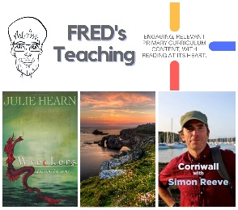 | 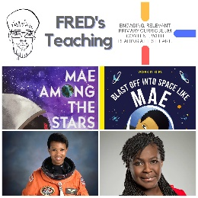 | 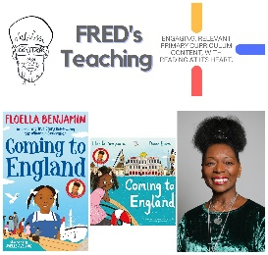 | 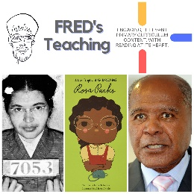 | 