Week 1 | Week 2 | Week 3 | Week 4 | Week 5 | Week 6
Theme: Remembrance | Theme: Remembrance | Theme: Environment | Theme: Environment | Theme: Christmas | Theme: Christmas
Extracts from:  - You Wouldn’t Want to be in the Trenches in World War One.  - The Story of World War One.  - Tail-end Charlie. | Extracts from:  - Daisy and the Unknown Warrior.  - Anne Frank’s Diary: The Graphic Adaptation.  - Letters from the Lighthouse. | Extracts from:  - Nen and the Lonely Fisherman.  - Climate Action.  - Plastic Sucks! | Extracts from:  - The Promise (full picture book).  - Cookie!... and the Most Annoying Girl in the World.  - Song of the Dolphin Boy. | Extracts from:  - How Winston Delivered Christmas.  - The Night I Met Father Christmas.  - Jingle All the Way movie trailer. | Extracts from:  - Another Night Before Christmas.  - The Christmasaurus.  - Elf movie trailer.
Content Domains covered: 2a, 2b, 2c, 2d, 2e, 2f, 2g, 2h | Content Domains covered: 2a, 2b, 2c, 2d, 2e, 2f, 2g, 2h | Content Domains covered: 2a, 2b, 2c, 2d, 2e, 2f, 2g, 2h | Content Domains covered: 2a, 2b, 2c, 2d, 2e, 2f, 2g, 2h | Content Domains covered: 2a, 2b, 2c, 2d, 2e, 2f, 2g, 2h | Content Domains covered: 2a, 2b, 2c, 2d, 2e, 2f, 2g, 2h
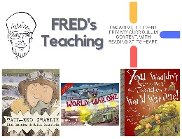 | 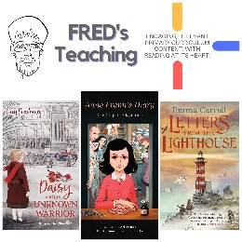 | 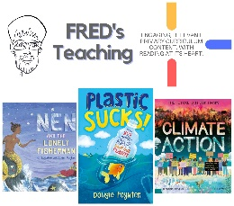 | 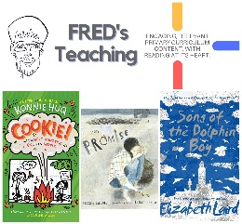 | 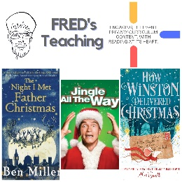 | 